Racism in the Air You Breathe: When Where You Live Determines How Fast You Die
More African Americans will die from environmental causes than from police brutality this year, yet there is no movement to stop the environmental racism that invades our neighborhoods and homes.
BY: CHARLES D. ELLISON
Posted: Aug. 17 2015 3:00 AM

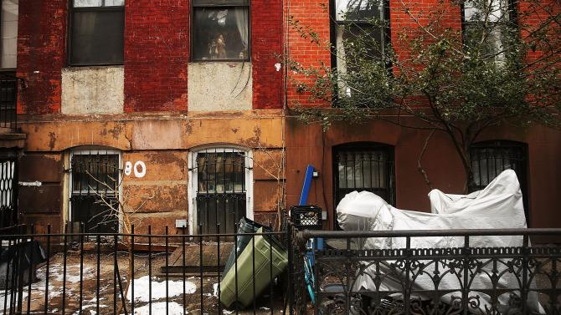
Two homes in the Fort Greene neighborhood of Brooklyn, N.Y., Feb. 27, 2014
SPENCER PLATT/GETTY IMAGES
Countless African-American neighborhoods are plagued by some of the worst ongoing environmental disasters that exist on the planet. There’s often a landfill, highway, airport or oil refinery next door. Nearby you can find contaminated bus depots, nasty subway stops, plus the lead in old houses, which can lead to neurological disorders and learning difficulties (pdf).
Many of us are so accustomed to living in polluted, chronically disease-ridden neighborhoods that this environmental racism is virtually ignored in civil rights movements. Yet a closer look at where black communities exist gives rise to the sudden recognition that it’s a sinister design. The reasons are as complex and knitted into Americana as they are numerous. “People may not understand what environmental racism is,” argues environmental sociologist Robert Bullard in a conversation with The Root.
“Racism keeps lower- to middle-income people of color stuck in danger zones,” says Bullard. “African Americans making $50,000 to $60,000 per year are way more likely to live in a polluted environment than poor white families making just $10,000 per year.”
And where you live—down to your exact zip code—can determine how fast you get sick and how soon you die.
If you could maintain a daily graphic of deaths caused by environmental racism, you’d end up finding far more black people dying from pollution than from racist cops. “Many people don’t see pollution and climate change as an immediate threat,” Green for All National Director Vien Truong explains to The Root. “People of color tend to live closer to sources of pollution, from coal plants to busy roads and highways. Our kids suffer higher rates of pollution-related illnesses: One in six black kids and one in nine Latino kids struggle with asthma. In California, twice as many people are now dying from traffic-related pollution than traffic-related accidents. These are environmental problems.”
And they’re enormous, making general ignorance of them frightening. Even the Environmental Protection Agency, comically toothless despite a mandate from its Office of Civil Rights to enforce explicit Title VI provisions in the Civil Rights Act of 1964, acknowledges that (pdf) “racial and ethnic minorities and poor children may be exposed to more pollution,” with “black children twice as likely to be hospitalized for asthma and four times as likely to die from asthma as white children.”
Two years ago the NAACP released its own report (pdf) and found that close to 80 percent of African Americans live within 30 miles of a coal-fired power plant, and nearly 40 percent of residents overall who live near coal-fired power plants are people of color. The top 12 plants with the lowest environmental-justice performance scores were within 3 miles of 2 million unsuspecting Americans—76 percent of them people of color.
In examining Eric Garner’s tragic choking death by New York City police, the Washington Post’s Max Ehrenfreund couldn’t ignore the larger cautionary tale of Garner’s asthma and how destructively prevalent the chronic disease is in black communities: “Blacks and whites actually breathe different air.”
The Center for American Progress’ Tracey Ross offers confidence that awareness will prevail, particularly if the #BlackLivesMatter movement expands its focus beyond its core. “We underestimate our ability to care about these issues,” Ross tells The Root, describing environmental-justice advocates as “the unsung heroes of our community.”
Still, Ross admits, “We do have immediate concerns that seem more pressing right now. Environmental racism is a slower, less dramatic process than someone getting shot by police.”
That it’s about air and water quality is a large part of the problem: Society generally abhors science dialogue, and it fails at nurturing what we take for granted. “It’s because we’ve lived with these problems for so many years, and it’s not until we get a major incident, like an explosion at a chemical plant or a spill at an oil refinery, that we start paying attention,” Bullard laments.
The Urban Institute’s Carlos Martín agrees, adding that “communities of color just haven’t had the resources to be proactive on this issue. It’s always reactive.”
As a result, black media and political institutions get universally slammed by many activists who see widespread community ignorance as a contributing factor. Even as President Barack Obama tussles with Republicans over his administration’s attempt at sweeping climate-change regulations, that effort isn’t exactly making front-page headlines in black newspapers or the morning drive on urban radio. The hashtag #environmentalracism shows up on Twitter, but it’s mostly white social media activists giving Bernie Sanders big ups as he frantically rolls out a new environmental-justice platform in a belated attempt to court #BlackLivesMatter.
“Environmental issues have always been perceived as something white people and hippies do,” Baltimore community activist and WEAA-FM radio host Catalina Byrd points out. “You can see the difference in the way mainstream media covered the president’s history-making climate-change deal with China in comparison to our media. We focus more on keeping score than on the details of the deal and how it would impact us.”
Scientific American blogger and “urban scientist” Danielle Lee agrees, faulting media and black politicians who “don’t recognize red flags when issues come across their desk.”
“Knowing what to pay attention to is a matter of science literacy. Science communication directly delivered to us is important,” Lee tells The Root. “Black media is the essential conduit for remedying our lack of activism and defense.”
But when a clear linkage is made between environmental conditions and the nonstop racism in housing, voting, employment and medical care, the so-called environmental-justice movement itself isn’t much help, either. Even Bullard, who helped spin off the movement in the 1980s after decades of getting short shrift from the civil rights vanguard, explains that the mainstream movement keeps bringing up class when it’s really about race.
“White environmentalist[s] talk about saving the rainforests, but no mention is ever made of saving the lives of those who dwell in America’s concrete jungles,” civil rights attorney Bryan K. Bullock wrote in Black Agenda Report. “Politicians, academics and activists have allowed the raw power of the word racism to be euphemized into words like justice, diversity, inclusion and equity.”
Ross also sees a language gap. The white environmental-justice complex won’t discuss the issue on a kitchen-table level with which everyday black folks can connect. Mainstream climate-change activists, for example, will sound the alarm on melting ice caps and disappearing polar bears, but there’s little conversation about black families being thrown out of homes post-Hurricane Katrina or post-Sandy because of a lack of resources and insurance. “When these catastrophes strike, these are never really ‘great equalizers,’” says Ross. “They exacerbate the larger socioeconomic challenges people of color are already faced with.”
Charles D. Ellison is a veteran political strategist and a contributing editor at The Root. He is also Washington correspondent for the Philadelphia Tribune, a contributor to The Hill, Sunday Washington insider for WDAS-FM in Philadelphia and a panelist on MSNBC’s Hardball With Chris Matthews.

